NPC
Natural Product Communications
2011
Vol. 6
No. 0
1 - 2

Distinguishing Between R- and S-Antcin C and Their Cytotoxicity

Ting-Yu Linª, Shih-Chang Chien^{b} , Yueh-Hsiung Kuo ^{d} and Sheng-Yang Wang^{a,b,c,e,f,*}

ªDepartment of Forestry, National Chung-Hsing University, Taichung, Taiwan

^{b}The Experimental Forest Management Office, National Chung-Hsing University, Taichung, Taiwan

^{c}Agricultural Biotechnology Center, National Chung-Hsing University, Taichung, Taiwan
^{d}Graduate Institute of Chinese Pharmaceutical Science, China Medical University, Taichung, Taiwan

^{e}Agricultural Biotechnology Research Center, Academia Sinica, Taipei, Taiwan
^{f}Agricultural Biotechnology Center, National Chung-Hsing University, Taichung, Taiwan

taiwanfir@dragon.nchu.edu.tw

Received: November 6th, 2011; Accepted: XX, 2011

Antcin C is a bioactive compound isolated from Antrodia cinnamomea, a rare and expensive medicinal fungus endemic to Taiwan. Up to date, the absolute structure of antcin C has not been solved. In this study, the phenylglycine methyl ester (PGME) derivatives of antcin C were prepared. From NMR analysis the absolute configuration of (S)-antcin C (1) and (R)-antcin C (2) were determined. By MTT assay, (S)-antcin C presented cytotoxicity against Hep G2 and MCF-7 cells, with IC₅₀ values of 14.5 and 12.8 μg/mL, respectively. However, (R)-antcin C did not show significant cytotoxicity. Our results showed that the configuration at C₂₅ for antcin C is very important for its cytotoxicity. From a quality control point of view, it is necessary to identify and quantify the R- and S- enantiomers in the A. cinnamomea products.

Keywords: Antrodia cinnamomea, (R)-Antcin C, (S)-Antcin C, Phenylglycine methyl ester, Absolute configuration, Cytotoxicity.

Antrodia cinnamomea (Syn. Antrodia camphorata and Taiwanofungus camphorata) (AC) is an edible fungus endemic to Taiwan that has long been used as a folk medicine for treating various diseases, including those of the liver, hypertension, abdominal pain, and cancer [1-3]. In our previous study [4], we demonstrated that ergostane-type steroids, including antcin A, B, C, G, and H are the major compounds in AC. Among these, antcin C has been proved to have significant anti-inflammation activity and to be cytotoxic [5, 6]. However, both R- and S-configurations exist in these ergostane-type steroids due to the C₂₅ chiral center (Figure 1).

The absolute conﬁguration of a chiral molecule is a fundamental and important property, especially when the compound has biological activity of potential therapeutic use [7]. Up to date, there is no related study on the absolute structure of ergostane-type steroids in AC. In the present work, the (R)- and (S)-phenylglycine methyl esters (PGME) of antcin C were prepared (PGME method) [8-10], which enabled the determination of the absolute configuration of the carboxylic acid. First, (R)- and (S)-PGME were reacted with (R)- and (S)-antcin C (1, 2), to synthesis their PGME derivatives, 1R, 1S and 2R, 2S (Figure 1).

By the PGME method, it was possible to assign the proton signals (chemical shift, δ) in the ¹H NMR spectrum of (R)- and (S)-PGME by calculating the differential of chemical shift values (Δδ) (Figure 2A) [11]. Accordingly, protons with positive Δδ in PGME were placed on the right-hand side, and those with a negative Δδ to the left-hand side (Figure 2B) [11]. Based on the model shown in Figure 2B, the configurations of 1 and 2 were assigned as (S)-antcin C and (R)-antcin C, respectively (Figure 2C).

After decided the absolute structures, Hep G2 and MCF-7 cells were used to evaluate the cytotoxicity of (R)- and (S)- antcin C. After 72 h of treatment, (S)-antcin C showed inhibitory activities against both Hep G2 and MCF-7 cell proliferation, with IC₅₀ values for Hep G2 and MCF-7 of 14.5 and 12.8 μg/mL, respectively
Figure 1: Structures of (S)-antcin C (1) and (R)-antcin C (2) isolated from the fruiting body of Antrodia cinnamomea

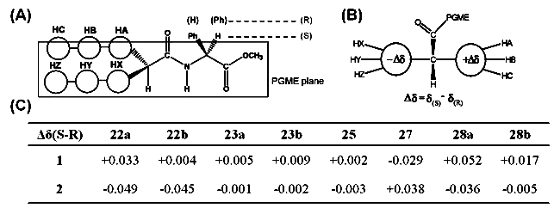
Figure 2: Model of conformational correlation for assignment of absolute configuration of (R)- and (S)-antcin C by NMR spectroscopy. (A) and (B) The model illustrates the absolute configuration at the C₂₅ position. (C) Δδ ( = δs – δ_{R}) values obtained from the ¹H NMR spectra of the PGME derivatives 1S, 1R and 2S, 2R.

(Figure 3). However, (R)-antcin C did not exhibit cytotoxicity to these two cell lines, even when the dosage reached 25 μg/mL. Similar results were also observed for hydroxylated triterpene alcohol ferulates isolated from rice bran [12]. In conclusion, this is the first study to distinguish the absolute structure of antcin compounds, which are enantiomers found in the AC fruiting body. Our results demonstrated that the absolute structure at C₂₅ for antcin C is very important for cytotoxicity. We suggest that it is necessary to consider the absolute structure for this group of compounds when investigating their bioactivity and application . Furthermore, from a quality control point of view, the individual quantification of (R)- and (S)-antcin in AC extracts and products should be calculated separately.

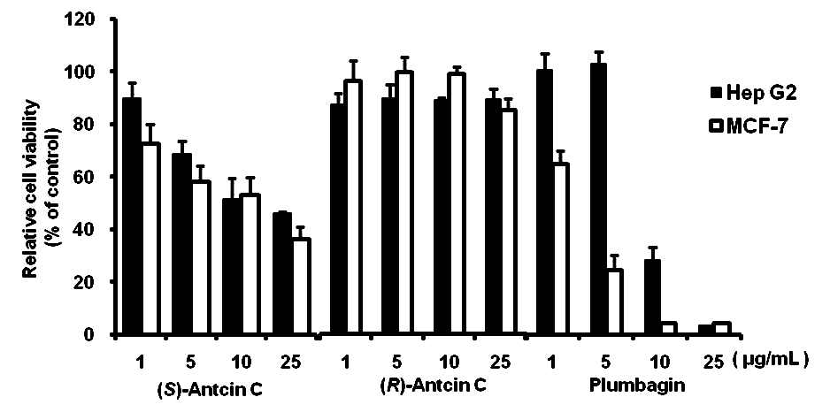
Figure 3: Cytotoxic activity of (R)-Antcin C, (S)-Antcin C, and plumbagin (reference compound) against Hep G2 and MCF-7 cell lines after 72 h treatment as determined by MTT assay. Data are given as mean ± SD (n = 3).

Experimental

Materials: The Antrodia cinnamomea strain was provided and identified by Dr Wen-Wei Hsiao (Experimental Forest, National Taiwan University). The fruiting bodies of AC were cultured in the Laboratory of Tree Metabolomics and Natural Medicine, Department of Forestry, National Chung-Hsing University between June, 2008 and December, 2009. Voucher specimens (AC-9) were deposited in the same laboratory.

Antcin C preparation and PGME derivatives synthesis: The ethanol extract preparation and separation procedure was described in our previous study [4]. Briefly, the ethanol extract was separated by HPLC using an Agilent 1100 HPLC system equipped with a UV detector. A Luna C18(2) column (250 × 10.0 mm; Phenomenex, Torrance CA) was employed with 3 solvent systems, H₂O (A), MeOH (B) and acetonitrile (C). The gradient elution profile was as follows: 0-5 min, A:B:C = 40:30:30 (isocratic); 5-95 min, A:B:C = 40:30:30 to A:B:C = 10:10:80 (linear gradient); 95-105 min, A:B:C = 10:10:80 to A:B:C = 0:0:100 (linear gradient); 105-115 min, 100% C (isocratic); the flow rate was 0.5 mL/min at 0-95 min; 1.0 mL/min at 95 to 115 min; and the detector wavelength was set at 254 nm. (S)-Antcin C and (R)-antcin C were obtained at retention times of 38.1 and 38.8 min, respectively. The structure of (R)-antcin C and (S)-antcin C were confirmed by spectral analysis and the spectroscopic data were in good agreement with the literature [13]. The absolute configuration measured was by condensation of (R)- and (S)-PGME, as described previously [8-10]. NMR spectra were recorded with Bruker Avance 500 and 300 MHz FT-NMR spectrometers, at 500 MHz (¹H) and 75 MHz (¹³C). d-Chloroform (CDCl₃) was used for NMR analysis.

Cytotoxicity evaluation: Hep G2 and MCF-7 cells were cultured in DMEM supplemented with 10% FBS and 1% penicillin–streptomycin, and were maintained at 37°C in 5% CO₂. All cells (1 × 10⁴ per well) were seeded in 96- well plates and incubated for 24 h, and different dosages (1, 5, 10, and 25 μg/mL) of (R)- and (S)- antcin C were added to each well in triplicate for 24 h. The cell viability was determined by the MTT method [14].

Acknowledgments - This work is supported in part by the Ministry of Education, Taiwan under the ATU plan.

References
- Hsieh YH, Chu FH, Wang YS, Chien SC, Chang ST, Shaw JF, Chen CY, Hsiao WW, Kuo YH, Wang SY. (2010) Antrocamphin A, an anti-inflammatory principal from the fruiting body of Taiwanofungus camphoratus, and its mechanisms. Journal of Agricultural, and Food Chemistry, 58, 3153 – 3158.
- Geethangili M, Tzeng YM. (2009) Review of pharmacological effects of Antrodia camphorata and its bioactive compounds. eCAM, doi: 10.1093/ecam/nep108.
- Ao ZH, Xu ZH, Lu ZM, Xu HY, Zhang XM, Dou WF. (2009) Niuchangchih (Antrodia camphorata) and its potential in treating liver diseases. Journal of Ethnopharmacology, 121, 194-212.
- Lin TY, Chen CY, Chien SC, Hsiao WW, Chu FH, Li WH, Lin J, Shaw JF, Wang SY. (2011) Metabolite profiles for Antrodia cinnamomea fruiting bodies harvested at different culture ages and from different wood substrates. Journal of Agricultural, and Food Chemistry, 59, 7626–7635.
- Shen YC, Chen CF, Wang YH, Chang TT, Chou CJ. (2003) Evaluation of the immuno-modulating activity of some active principles isolated from the fruiting bodies of Antrodia camphorata. Chinese Pharmaceutical Journal, 55, 313-318.
- Yeh CT, Rao YK, Yao CJ, Yeh CF, Li CH, Chuang SE, Luong JHT, Lai GM, Tzeng YM. (2009) Cytotoxic triterpenes from Antrodia camphorata and their mode of action in HT-29 human colon cancer cells. Cancer Letter, 285, 73-79.
- Hoye TR, Jeffrey CS, Shao F. (2007) Mosher ester analysis for the determination of absolute configuration of stereogenic (chiral) carbinol carbons. Nature Protocol, 2, 2451-2458.
- Macias FA, Varela RM, Simonet AM, Culter HG, Culter SJ, Hill RA. (2003) Absolute configuration of bioactive expansolides A and B from Aspergillus fumigatus Fresenius. Tetrahedron Letters, 44, 941-943.
- Yabuuchi T, Kusumi T. （2000) Phenylglycine methyl ester, a useful tool for absolute configuration determination of various chiral carboxylic acids. Journal of Organic Chemistry, 65, 397-404.
- Ferreiro MJ, Latypov SK, Quinoa E, Riguera R. (2000) Assignment of the absolute configuration of α- chiral carboxylic acids by ¹H NMR spectroscopy. Journal of Organic Chemistry, 65, 2658-2666.
- Nagai Y, Kusumi T. (1995) New chiral anisotropic reagents for determining the absolute configuration of carboxylic acids. Tetrahedron Letters, 36, 1853-1856.
- Luo HF, Li Q, Yu S, Badger TM, Fang N. (2005) Cytotoxic hydroxylated triterpene alcohol ferulates from rice bran. Journal of Natural Products, 68, 94-97.
- Cherng IH, Chiang HC. (1995) Three new triterpenoids from Antrodia cinnamomea. Journal of Natural Products, 58, 365-371.
- Cheng WL, Lin TY, Tseng YH, Chu FH, Chueh PJ, Kuo YH, Wang SY. (2011) Inhibitory effect of human breast cancer cell proliferation via p21-mediated G₁ cell cycle arrest by araliadiol isolated from Aralia cordata Thunb. Planta Medica, 77, 164-168.

